Name: Venkata Vamsi Siva Krishna Vura

Student ID:16147665

Google Service :

It is used to find the target location from the present location

HTML location:

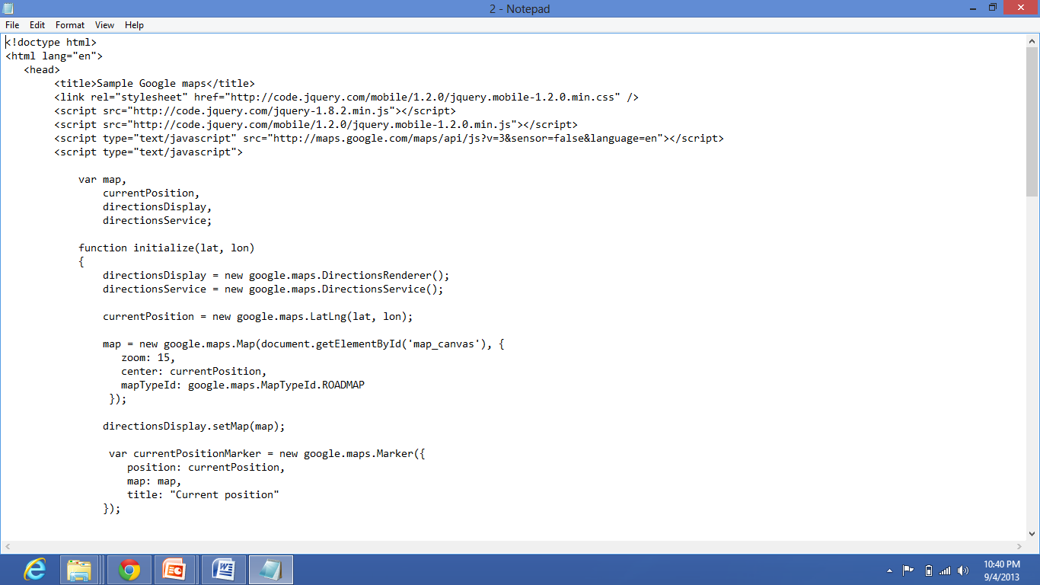

The working of the application to find the st louis from the current location(harrison street,kansas city)

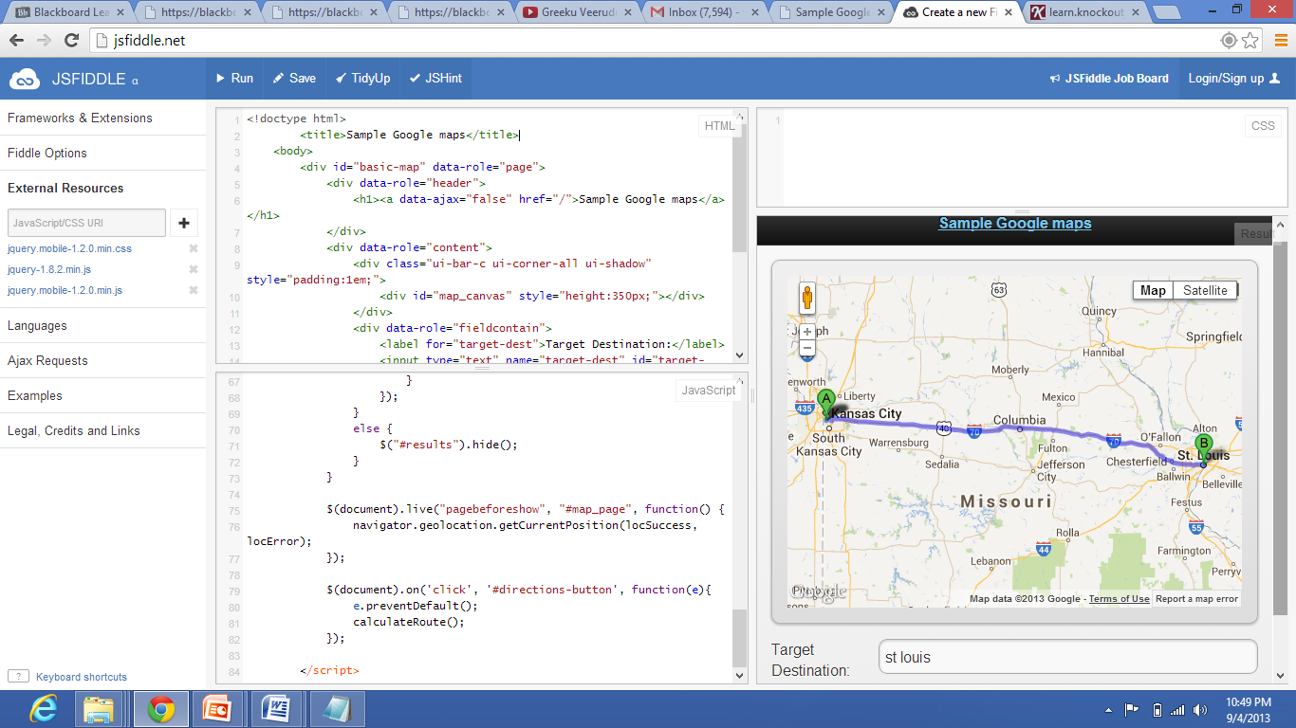

Here I add the jquery mobile versions on the left panel in the external resources

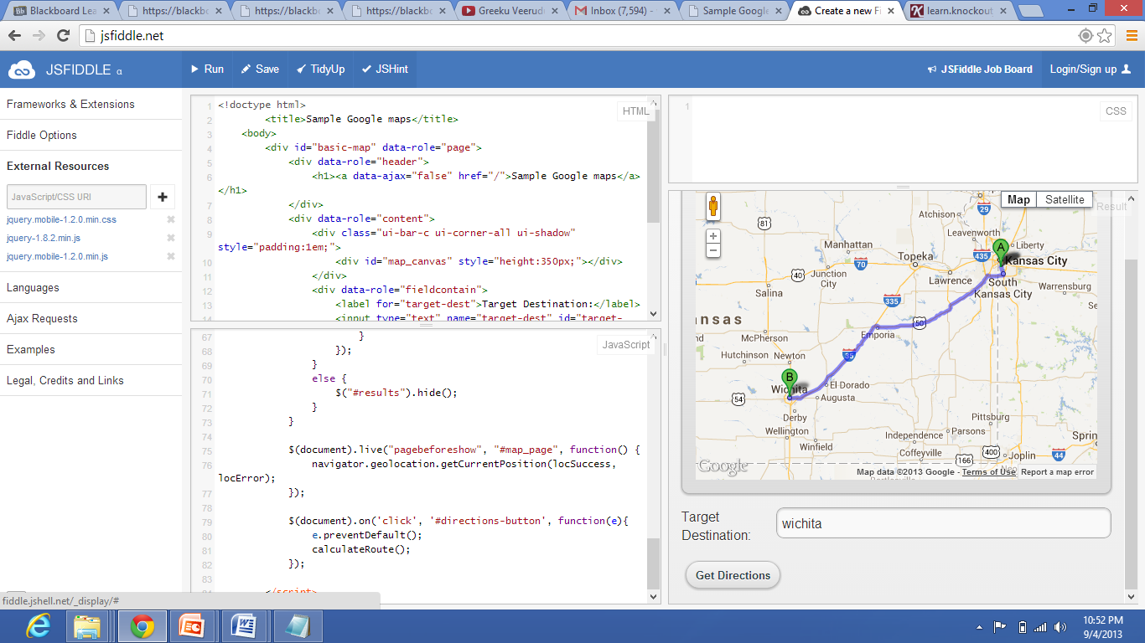

In the above application jquery mobile is added as the external resource and all the jquery versions are added.

Here I used the google services and it is used to find the target from the current location.

It is used to know the route map and the distances for the exits.

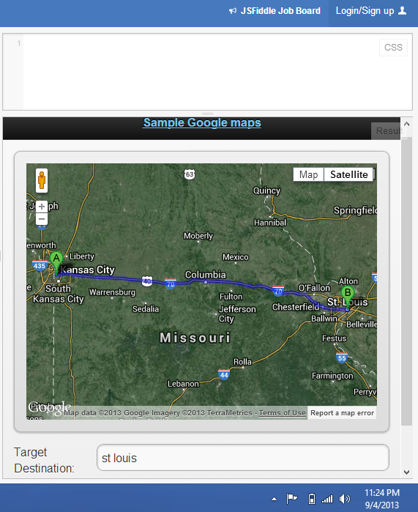

Satellite view of the destination